**Future Forward: Smart Traffic, Parking, and Waste Systems for the Modern City"**

**Course Title: IOT Protocols**

**Instructor Name: Dr. Abdelwahab Fawzy**

**By:**

**Fatima al_zhra**

**Muhammed majid**

**Ahmed athour**

**Abdelruhman yasser**

**Overview**

This project is a mini smart city prototype that includes three main systems: a Smart Trash Bin, Smart Parking, and Smart Traffic Lights. Each system uses IoT technology (ESP8266/ESP32 and sensors) to improve city services.

The trash bin detects fill level and sends alerts, the parking system shows real-time availability, and the traffic lights adjust based on vehicle flow. A Flutter app was also developed to help users find free parking spots quickly.

Overall, the project aims to make urban life more efficient, organized, and environmentally friendly using low-cost smart technologies. . This report details the design, implementation, and performance of the system, highlighting its effectiveness in detecting and extinguishing fires in inaccessible locations, Table of Contents

**Sections**

1. Introduction
2. Background
3. Project Description
4. Used components
5. Assembly instructions
6. Appendices
7. Introduction
8. This project introduces a simplified Smart City model that uses IoT technology to improve daily urban services. It includes three main systems: a Smart Trash Bin that detects fill levels, a Smart Parking System that shows real-time slot availability, and a Smart Traffic Light that adjusts based on vehicle flow. The systems are built using ESP8266/ESP32 and sensors.
9. A Flutter mobile app was also developed to help users find free parking spots. The goal is to show how smart technologies can make cities cleaner, safer, and more efficient.



1. Background

This project aims to create a mini Smart City prototype focusing on three key systems: Smart Trash Bin, Smart Parking, and Smart Traffic Lights. These systems use IoT technology (ESP8266/ESP32, sensors) to improve urban living by addressing issues like waste management, parking, and traffic congestion.

* **Smart Trash Bin**: Uses ultrasonic sensors to detect when the bin is full and sends notifications for timely collection, optimizing waste management.
* 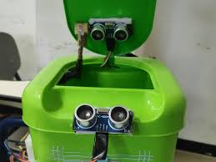
* **Smart Parking**: Monitors parking space availability in real-time with ultrasonic sensors and helps drivers find free spots quickly through a Flutter mobile app.

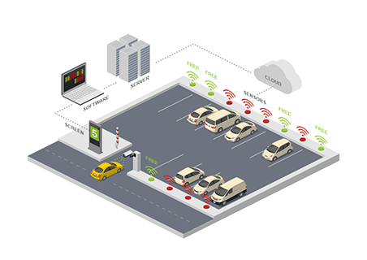

* **Smart Traffic Lights**: Adjusts signal timing based on real-time traffic flow, reducing congestion and improving traffic efficiency.
* 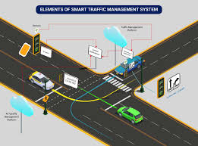

The project demonstrates how low-cost, scalable IoT solutions can enhance city services, reduce inefficiencies, and improve the overall quality of life in urban environments.

1. Project Description

🔹 Objective: The goal of this project is to build a small Smart City model that includes three systems: Smart Trash Bin, Smart Parking, and Smart Traffic Lights. These systems use IoT (ESP8266/ESP32 and sensors) to improve efficiency in waste management, parking, and traffic flow. A Flutter app is also developed to show parking availability in real time

🔹 Problem Statement:

Cities suffer from issues like overflowing trash bins, difficulty finding parking, and traffic congestion due to poor signal timing. These problems need smart, automated solutions to improve urban life

🔹 Applications:

The project can be applied in cities, universities, malls, hospitals, and public spaces. It helps in smart waste collection, guiding cars to empty parking slots, and controlling traffic flow automatically

**4. Used Components**

| **Component** | **Quantity** | | | **Unit Price (USD)** | | | **Total Price (USD)** | **Notes** | |
| --- | --- | --- | --- | --- | --- | --- | --- | --- | --- |
| **ESP32** | 1 | | | $6.00 | | | $6.00 | Estimated price for ESP32 development board. | |
| **ESP8266** | 1 | | | $0.55 | | | $0.55 | Price for ESP8266EX chip. | |
| **IR Sensor** | 4 | | | $0.50 | | | $2.00 | Approximate price per IR sensor. | |
| **Servo Motor** | 3 | | | $3.00 | | | $9.00 | Estimated price for standard servo motors. | |
| **Ultrasonic Sensor**  **Jumpers** | | 1 | $0.50 | | $0.50 | Price for HC-SR04 ultrasonic sensor. | | |
| **Total** | | — | — | | **$18.05** |  | | |

**Circuit diagram:**

**ESP32 Microcontroller:**

• **Manufacturer**: Espressif Systems

• **CPU**: Dual-core Xtensa LX6 (32-bit), operating at 160 or 240 MHz

• **Memory**: 520 KiB SRAM

• **Wireless Connectivity**: Wi-Fi 802.11 b/g/n and Bluetooth v4.2 BR/EDR and BLE

• **GPIOs**: Up to 34 programmable GPIOs

• **Interfaces**: 4× SPI, 2× I²C, 2× I²S, 3× UART, 2× 12-bit SAR ADCs (up to 18 channels), 2× 8-bit DACs

• **Security Features**: Secure boot, flash encryption, cryptographic hardware acceleration (AES, SHA-2, RSA, ECC), random number generator (RNG)

• **Power Management**: Deep sleep current as low as 5μA​

**ESP8266 Microcontroller**

| **Feature** | **Description** |
| --- | --- |
| **CPU** | 32-bit Tensilica L106, up to 160 MHz |
| **RAM** | 80 KB user RAM |
| **Flash Memory** | External flash support (usually 512 KB to 4 MB) |
| **Wi-Fi** | 802.11 b/g/n (2.4 GHz), supports WPA/WPA2 |
| **I/O Pins** | Up to 17 GPIOs (depending on the module version) |
| **Interfaces** | SPI, UART, I²C (software), PWM, ADC (1 channel) |
| **Operating Voltage** | 3.0V – 3.6V |
| **Power Consumption** | ~70mA during operation, <1mA in deep sleep |
| **Dimensions** | Varies by module (e.g., ESP-01, ESP-12) |



